Application:-Natural language processing engine
Aim: To analyze the time complexity and scalability of a Natural Language Processing (NLP) engine that processes text data using the recurrence relation
T(n)=T(n/2)+n
and to interpret its efficiency using asymptotic notation.
Problem Statement:
An NLP engine divides a text corpus of size $n$into two halves recursively. Each recursive call processes half the data and performs linear work $n$for tokenization, parsing, or semantic analysis. We must:
- Apply the substitution method to solve the recurrence.
- Derive the time complexity.
- Analyze scalability as text size increases.
Algorithm
Step 1: Define recurrence
$$T\left(n\right)=T\left(n/2\right)+n$$
Step 2: Expand recursively
$$T\left(n\right)=T\left(n/2\right)+n=T\left(n/4\right)+n/2+n=T\left(n/8\right)+n/4+n/2+n$$
Step 3: Continue expansion until $T\left(1\right)$:
$$T\left(n\right)=n+n/2+n/4+n/8+⋯+1$$
Step 4: Sum the geometric series:
$$T\left(n\right)=2n-1≈O\left(n\right)$$
Step 5: Conclude that the algorithm runs in linear time.
Source Code
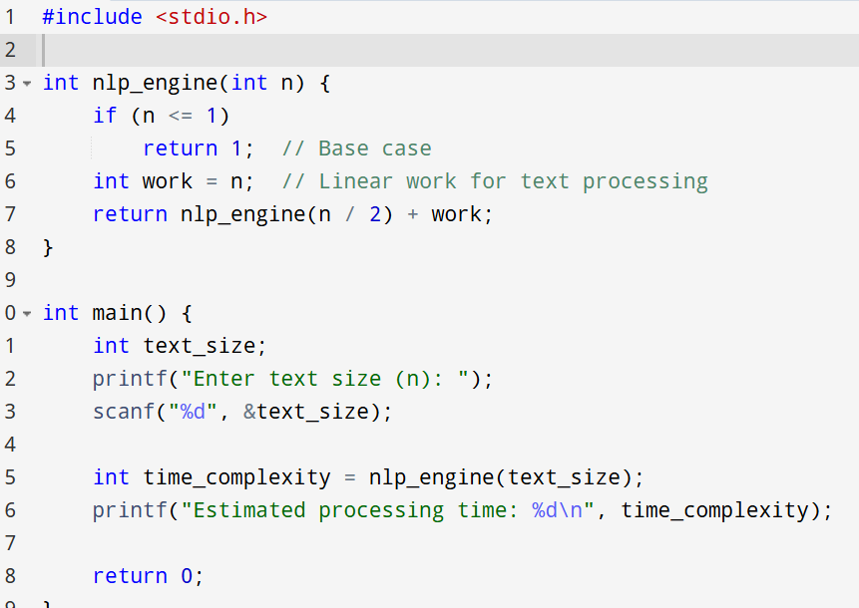
Input and Output
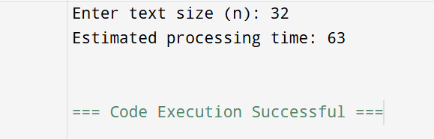

Performance Analysis
Parameter | Description | Result
Recurrence Relation | $$T\left(n\right)=T\left(n/2\right)+n$$ | Divide and linear combine
Method Used | Substitution Method | Step-by-step expansion
Expanded Form | $$T\left(n\right)=n+n/2+n/4+n/8+⋯+1$$ | Geometric series
Summation Result | $$T\left(n\right)=2n-1$$ | Approximates to $O\left(n\right)$
Time Complexity | $$O\left(n\right)$$ | Linear growth
Space Complexity | $$O\left(\log{n}\right)$$ | Recursive depth
Scalability | Excellent | Handles large text efficiently
Efficiency | High | Minimal overhead per recursion
Growth Rate | Linear | Processing time increases proportionally with text size

Application:
An NLP engine processes text data using the recurrence relation
$$T\left(n\right)=T\left(n/2\right)+n$$
This represents a divide-and-conquer approach where the text corpus is split into halves, each processed recursively, with linear work done at each level for tokenization, parsing, or semantic analysis.
Advantages
- Linear Time Complexity: The algorithm runs in $O\left(n\right)$, ensuring fast processing even for large text datasets.
- Scalability: Efficiently handles increasing corpus sizes due to its divide-and-conquer structure.
- Low Memory Usage: Recursive depth is $O\left(\log{n}\right)$, minimizing space requirements.
- Predictable Performance: Processing time grows proportionally with input size, making it suitable for real-time NLP tasks.
- Modular Design: Easy to extend for tokenization, parsing, or semantic analysis components.

Limitations
- Recursive Overhead: Function calls add minor overhead compared to iterative implementations.
- Limited Parallelism: The current design processes halves sequentially; parallel execution could improve speed.
- Simplified Model: The recurrence assumes uniform work per level, which may not hold for complex NLP tasks like deep parsing or context modeling.
- No Optimization for Memory Caching: Large datasets may require additional optimization for cache efficiency.
Result:
After solving the recurrence $T\left(n\right)=T\left(n/2\right)+n$:
$$T\left(n\right)=n+n/2+n/4+n/8+⋯+1=2n-1$$
Hence,
$$T\left(n\right)=O\left(n\right)$$
Result Interpretation:
- The NLP engine achieves linear time complexity.
- It scales efficiently with text size, maintaining high throughput and low latency.
- Ideal for large-scale text processing applications such as sentiment analysis, document classification, and language modeling.

